Report2_ Project Management Plan


CAPSTONE PROJECT REPORT
Report 2 – Project Management Plan

– Da Nang, December 2024 –

TABLE OF CONTENTS
I. Record of Changes 3
II. Project Management Plan 4
1. Overview 4
1.2 Scope & Estimation 4
1.2 Project Objectives 7
1.3 Project Risks 7
2. Management Approach 8
2.1 Project Process 8
2.2 Quality Management 9
2.2.1 Review Processes 9
2.2.2 Task Tracking/Covering Processes 9
2.2.3 Test Processes 10
2.2.4 Defect Prevention, Project Scope, and Document 10
2.3 Training Plan 11
3. Project Deliverables 11
4. Responsibility Assignments 11
5. Project Communications 12
6. Project Communications 14
6.1 Document Management 14
6.2 Source Code Management 15
6.2.1 Manage Source Code of Front-End 15
6.2.2 Manage Source Code of Back-End 17
6.3 Tools & Infrastructures 18

TABLE OF TABLES
Table 1. Scope & Estimation 6
Table 2. Project Objectives 7
Table 3. Project Risks 8
Table 4. Review Processes 9
Table 5. Task Tracking/Covering Processes 10
Table 6. Test Processes 10
Table 7. Defect Prevention, Project Scope, and Document 10
Table 8. Training Plan 11
Table 9. Project Deliverables 11
Table 10. Responsibility Assignments 12
Table 11. Project Communications 13
Table 12. Document Management 14
Table 13. Tools & Infrastructure 18

TABLE OF FIGURES
Figure 1. Scrum Model 9
Figure 2. Manage Source Code of Front-End for Customer 15
Figure 3. Manage Source Code of Front-End for Driver 16
Figure 4. Manage Source Code of Front-End for Web 16
Figure 3. Manage Source Code of Back-End 17

I. Record of Changes
Date | A*, M, D | In charge | Change Description
25/08/2024 | A | FRide Team | Add initial version
24/09/2024 | M | FRide Team | Update the mentor’s comment
10/12/2024 | M | FRide Team | Update scope and estimation
*A - Added M - Modified D- Deleted

II. Project Management Plan

1. Overview

1.1 Scope & Estimation

# | WBS Item | Complexity | Est. Effort  (man-day)
1 | Authenticate |  | 6
1.1 | Sign in with phone and password | Simple | 2
1.2 | Sign up for a new account | Medium | 3
1.3 | Sign out | Simple | 1
2 | Manage accounts |  | 7
2.1 | View profile | Simple | 2
2.2 | Update profile | Medium | 2
2.3 | Change password | Medium | 2
2.4 | Forgot password | Simple | 1
3 | Manage users |  | 16
3.1 | View information of driver | Medium | 3
3.2 | Lock account users | Medium | 2
3.3 | View information list users | Medium | 2
3.4 | View activity history | Medium | 3
3.5 | View revenue | Complex | 3
3.6 | Approve driver registry request | Complex | 3
4 | Manage services |  | 16
4.1 | Book a trip | Complex | 5
4.2 | Hire a driver | Complex | 4
4.3 | Create a carpool | Complex | 4
4.4 | Join a carpool | Complex | 3
5 | Manage trips |  | 26
5.1 | Cancel trip | Complex | 3
5.2 | Track driver location | Complex | 3
5.3 | View route | Complex | 2
5.4 | Update pickup status | Complex | 2
5.5 | Update request status | Medium | 2
5.6 | View trip requests | Medium | 2
5.7 | Accept carpooling request | Medium | 2
5.8 | View carpool request information | Medium | 2
5.9 | Update activity status | Medium | 2
5.10 | Select service | Medium | 2
5.11 | View list carpool request | Medium | 2
5.12 | View details information carpool request | Medium | 2
6 | Manage payment and price |  | 9
6.1 | Pay online | Complex | 3
6.2 | View price of each service | Medium | 2
6.3 | Update price of each service | Medium | 2
6.4 | Process withdrawal requests | Medium | 2
7 | Manage statistics |  | 5
7.1 | View statistics | Medium | 2
7.2 | Search data trips/users | Medium | 2
7.3 | Export to Excel files of data | Medium | 1
8 | Manage feedback |  | 8
8.1 | Feedback driver | Medium | 2
8.2 | View list feedback of driver | Medium | 2
8.3 | View detail feedback | Medium | 2
8.4 | View average rate | Medium | 2
9 | Manage notification and communication |  | 6
9.1 | View notification | Medium | 2
9.2 | Call phone number | Medium | 1
9.3 | Chat real time | Complex | 3
10 | Manage discount |  | 5
10.1 | CRUD discount | Complex | 3
10.2 | Use discount | Medium | 2
 | Total Estimated Effort (man-days) |  | 104

Table 1. Scope & Estimation

1.2 Project Objectives
The testing metrics we aim for during project implementation are as follows:
# | Testing Stage | Test Coverage | No. of Defects | % of Defect | Notes
1 | Reviewing | 100% | 15 | 5% | Technical leader reviews code of members before merging
2 | Integration Test | 95% | 10 | 5% | The tester creates and tests
3 | System Test | 90% | 5 | 10% | The tester creates and tests
4 | Acceptance Test | 90% | 5 | 10% | User verifies system

Table 2. Project Objectives

1.3 Project Risks
The risks that our project may face are as follows:
# | Risk Description | Impact | Possibility |  | Response Plans
1 | Legal risk | High | Medium to High (depending on the content) |  | - Create clear rules for what types of content are allowed on the website, and explain these rules in the terms of service.  - Set up a system for users to flag content that breaks rules or is inappropriate.  - Have clear plans to review or delete flagged content if needed quickly.
2 | Technical difficulties | High | High |  | - Carefully assess the skills and experience of the team to ensure that they are capable of building the website as planned.  - Provide additional training or resources to help team members acquire the necessary skills.
3 | Poor Project Schedule | Medium | Medium |  | - Clearly define the project schedule and make sure that team members know what they need to do and when.  - Make sure that everyone follows the schedule.
4 | Scope of project | High | Medium |  | - Regularly review the scope of the project and set priorities for what topics will be worked on first.  - Having the ability to trim the project as a progression due to the open nature of the project.
5 | Acceptance Test | High | Low to Medium |  | - Use strong security measures, like encrypting data and keeping the server secure.  - Regularly update security to stay ahead of potential threats.

Table 3. Project Risks

2. Management Approach

2.1 Project Process
In this project, our team has agreed to use the Scrum methodology to approach the project.
We split the project execution time into 5 sprints as below:
- Sprint 1:
  - Deliverables: Project preparation, database design, UI design
  - Daily Scrum: Meeting 15 minutes a day to exchange work between the development team.
  - Start date: 05/09/2024
  - End date: 16/09/2024
- Sprint 2:
  - Deliverables: User’s feature UI design, User’s feature
  - Daily Scrum: Meeting 15 minutes a day to exchange work between the development team.
  - Start date: 16/09/2024
  - End date: 07/10/2024
- Sprint 3:
  - Deliverables: Driver’s feature UI design, Driver’s feature
  - Daily Scrum: Meeting 15 minutes a day to exchange work between the development team.
  - Start date: 07/10/2024
  - End date: 28/10/2024
- Sprint 4:
  - Deliverables: Admin’s feature UI design, Admin’s feature, Report 3, Report 4, Report 5
  - Daily Scrum: Meeting 15 minutes a day to exchange work between the development team.
  - Start date: 28/10/2024
  - End date: 18/11/2024
- Sprint 5:
  - Deliverables: Other features, Report 1, Report 2, Report 6, Report 7
  - Daily Scrum: Meeting 15 minutes a day to exchange work between the development team.
  - Start date: 18/11/2024
  - End date: 02/12/2024
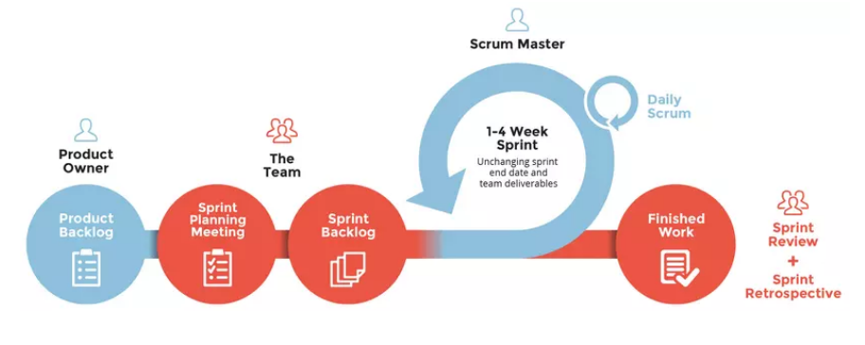

Figure 1. Scrum Model

2.2 Quality Management
FlexiRide uses some quality management approaches to ensure that the project output is of adequate quality and suitable, ensuring and managing the quality throughout the software development life cycle (SDLC) efficiently.

2.2.1 Review processes
The review processes we aim for during project implementation are as follows:
Step | Action | Description
1 | Peer-Review | The specific complete task will be reviewed by other members
2 | Group Review | All members will join a meeting to review the complete tasks of specific members to verify their development quality based on the given requirement
3 | Mentor Feedback | The finished sections will be reviewed and approved by the mentor, If any mismatches or incorrect standards, they will raise feedback notes for change and have another section to review again

Table 4. Review Processes

2.2.2 Task Tracking/Covering Processes
The task tracking/covering processes we aim for during project implementation are as follows:
Step | Action | Description
1 | Daily Report | Each member will manage their detailed work on Trello, moving task cards through stages. Manage detailed work in real-time. This helps track daily progress, keeping the whole team updated regularly.
2 | Weekly Report | Consolidate data from Trello into Google Sheets to create weekly reports. Team members fill in necessary progress information and notes on the board. The overall report helps managers grasp the overall project and team situation weekly.

Table 5. Task tracking/Covering Processes

2.2.3 Test Processes
The test processes we aim for during project implementation are as follows:
Step | Action | Description
1 | System Testing | Each member will test their part and the rest of the team members will peer-review each other

Table 6. Test Processes

2.2.4 Defect Prevention, Project Scope, and Document
The defect prevention, project scope, and document we aim for during project implementation are as follows:
Step | Action | Description
1 | Defect Prevention | Spend more time improving skills for using Unit to write test cases to ensure the product minimizes errors in the process of user use.
2 | Project Scope | Management of changes to project scope: Planning for possible changes through proper risk analysis or keeping track of all types of possible unanticipated issues.
3 | Document | After each code and test process, write a report on the parts you have done so that all members can understand the situation of the product being made

Table 7. Defect Prevention, Project Scope, and Document

2.3 Training Plan
The training plan we aim for during project implementation is as follows:
Training Area | Participants | When, Duration | Waiver Criteria
Review ReactJs, Nodejs, MongoDB | All members | 05-08-2024, 1 weeks | Mandatory
React Native | All members | 12-08-2024, 3 weeks | Mandatory
Git, GitHub | All member | 03-09-2024, 1 day | Mandatory

Table 8. Training Plan

3. Project Deliverables
The timeline by which we will deliver the items below:
# | Deliverable | Due Date | Notes
1 | Report1_Project Introduction | 02/12/2024 | N/A
2 | Report2_Project Management Plan | 02/12/2024 | N/A
3 | Report3_Software Requirement Specification | 02/12/2024 | N/A
4 | Report4_Software Design Document | 02/12/2024 | N/A
5 | Report5_Test Documentation | 02/12/2024 | N/A
6 | Report6_Software User Guides | 02/12/2024 | N/A
7 | Report7_Final Project Report | 02/12/2024 | N/A
8 | Source Code | 02/12/2024 | N/A

Table 9. Project Deliverables

4. Responsibility Assignments
To implement the project effectively, we rely on the following:
D~Do; R~Review; S~Support; I~Informed; <blank>- Omitted

Responsibility | ThinhPH | HuyNTT | TrieuTĐ | MaiTTT | ThinhNT
Project Planning & Tracking | D | R | R | R | S
Project Introduction Document | R | D | R | D | I
Project Management Plan | D | R | D | I | R
SRS Document | D | S | D | S | R
Use Case Specifications | D | S | R | D | S
Software Design Document | S | D | I | D | R
Coding Authenticate Feature | I | D | R | D
Coding Manage User Accounts Feature | R | D | S | S | I
Coding Manage Driver Accounts and Driver Vehicles Feature | S | I |  | D | R
Coding Booking a Trip Feature | S |  | D | R | S
Coding Hire Driver Feature | D | R | S |  | S
Coding Share a Trip (Carpooling) Feature | R |  | S |  | D
Coding Manage Revenue And Payment Feature | D |  | R | D | I
Coding Manage Price And Discount Feature | S | D | I | R
Coding Manage Feedback Feature | D | D | R | S
Coding Manage Activity History Feature |  | S | D | R | D
Software Test Documentation | I | D | R | D | S
Testing | D | S | D | S | R
Software User Guides | R | S | S | D | R
Deployment | R | S | D |  | S
Project Report | D | S |  | I | R
Prepare Presentation Slide | D | R | R | D | I

Table 10. Responsibility Assignments

5. Project Communications
The project communications we aim for during project implementation are as follows:

Communication Item | Who/ Target | Purpose | When, Frequency | Type, Tool, Method(s) Plans
Weekly Meeting | All members and mentor | Report process  Review product  Feedback | 20h00, Tuesday | Google Meet
Daily Stand-up | All members | Reports daily  Tracking process  Review a product  Assigning tasks | 22h00, Daily | Google Meet

Table 11. Project Communications

6. Project Communications

6.1 Document Management
All documents are managed on Google Drive and only team members have permission to edit. In addition, we always prepare a backup when it is necessary or the folder is unfortunately removed. The folder structure is organized as shown below.
- Workplace: Store template documents and references
- Review: Store document that mentor’s reviews
- FlexiRide: Store the document’s final version
- WIP: Store work-in-process document
Folder | Meaning
Backup | Contains backup files to prevent data loss while working
FlexiRide | Contains finished items with new versions and ready to review, almost no changes to the files in this folder
Review | Contains reviewed items with feedback
Workplace | Contains references, templates, and related files
WIP | Contains unfinished files that members are working on. We also have a folder called users inside this folder; each team member stores their work in separate subfolders inside users.

Table 12. Document Management

6.2 Source Code Management
We use Github to manage the source code that we do for this project. For this project, we have a special branch called main. All members will push the code at the end of the day when they have finished their tasks.

6.2.1 Manage Source Code of Front-End
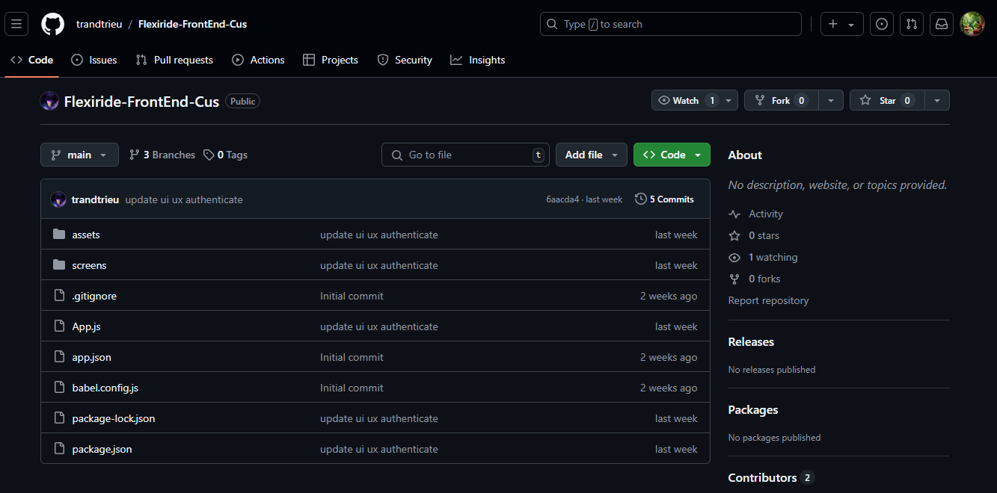

Figure 2. Manage Source Code of Front-End for Customer

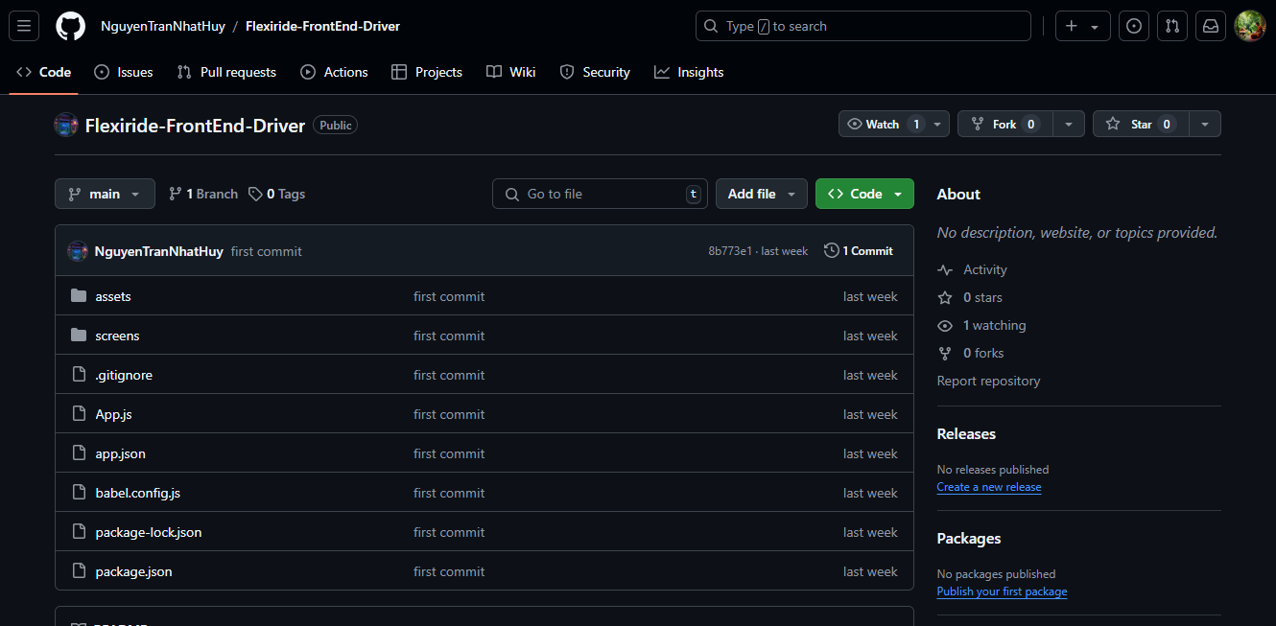

Figure 3. Manage Source Code of Front-End for Driver

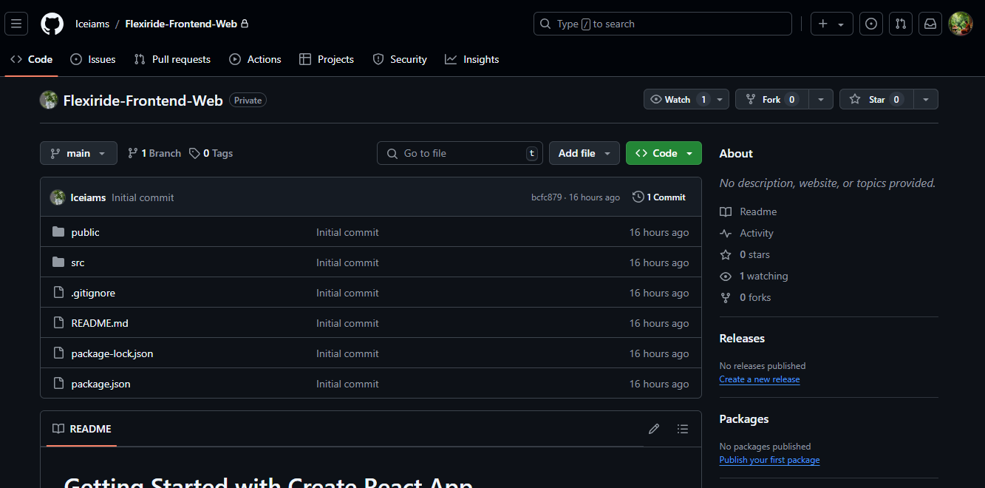

Figure 4. Manage Source Code of Front-End for Web

6.2.2 Manage Source Code of Back-End
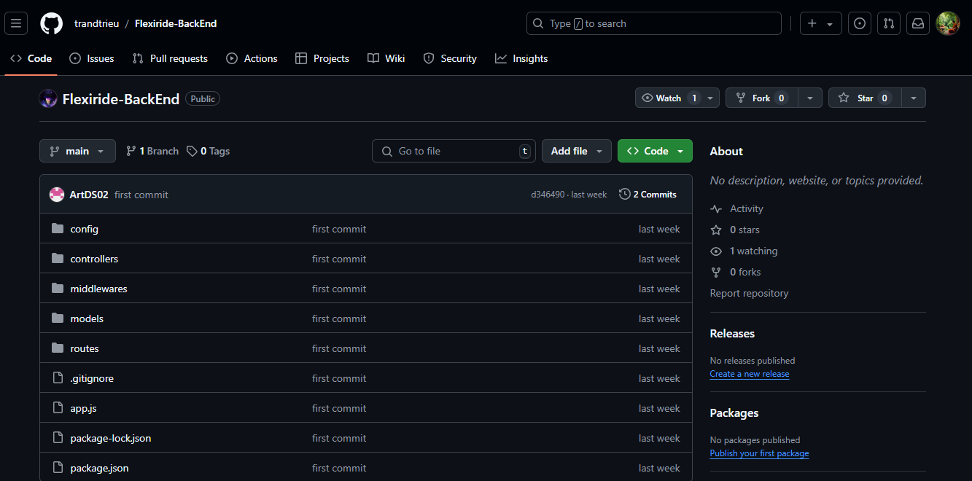

Figure 3. Manage Source Code of Back-End

6.3 Tools & Infrastructures
The tools and infrastructures we aim for during project implementation are as follows:
Category | Tools / Infrastructure
Develop Process | Agile methodology
Programming languages | HTML, CSS, Javascript, Typescript
Framework/ Library | ReactJS, NodeJS, React Native
Database | MongoDB
IDEs/Editors | Visual Studio Code, Android Studio
Diagramming | DrawIO
Documentation | Microsoft Office, Google Docs/Sheets/Slides
Version Control | GitHub(Source Codes), Google Drive (Documents)
Deployment server | Render Service
Project management | Google Drive, Google Sheets, Facebook Group, Zalo Group, Trello

Table 13. Tools & Infrastructure

